Answers
Q1.
- When an object is thrown upwards it decelerates under the influence of the earth;s gravity. The speed of the object decreases until it attains maximum height where the velocity is zero.
- The
- F= m*a
A = v/t
F = m*v/t
F= kg m/s²
- The
- The objects velocity is positive when the graph is moving upwards and horizontally.
(ii)The objects velocity is negative when the garaph begins to move downwards.
(iii)Yes the object returns to its starting point. This is because the objet is thrown upwards and starts to decelerate downwards to the point of origin.
(f) The object is not moving when the time is at 3 seconds and 10 seconds. Here as seen from the graph the velocity is zero.
(ii) at 8 m/s second the velocity remains constant for a period of two seconds.
(iii) From 3 to 6 seconds the velocity increases.
(iv) From 6 to 10 seconds the velocity decreases.
(v) The object doesnot return to its point of origin. This because the object is not oving in the upward direction.
Collision | Kinetic energy conserved | Momentum conserved
Elastic | Yes | Yes
Inelastic | No | Yes

Q2.
- √2h/g
- v√2h/g
(b) 9.81*1 = 9.81m/s
(ii) 9.81*2= 19.62 m/s
(iii) y= ½ gt2
=1/2 *9.81*2²
= 19.62 m
Iv)
C)
- y= ½ gt2
=1/2 *9.81*1
= 49 m
Y= vt+ ½ at²
⁼ 1+ 49= 50 m
- x= v*t= 1m
- t= √2h/g
=40/9.81
= 2.0 seconds
Q3
- Point A
Kinetic energy= 0
Potential energy= mgh= 550*9.81*28= 151074 kg m2/s2
Point B
Point C
Point D
- ½ mv2 = mgh
275v2= 80932.5
V= 17.14 m/s
Q4 Friction
- Draw
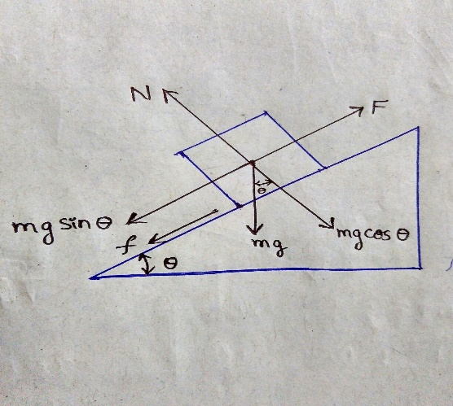
- Fp= Fn + w
Fp= pulling force
Fn= normal force
W= weight of the object.
- Fk = W sin 30
50 sin 30
= 49.4 N
- Ax = g sin 30 – uk g sin 30
=9.81 sin 30- 0.4*9.81 sin 30
= 10.3 m/s²
Q5 Work done
- W= F*d
60* 0.7 = 42 N m
- F = ma
50*9.81*5 = 2452.5 N m
- W = F*d cos 30
W= 120 *8 cos 30
W =148.08 N m
Q6. Hooke’s law and spring
- F = Kx
K= 4/0.11= 36.36 N/m
- This means that the extended distance is linear with respect to the weight added.
- X= 730- 620= 110 mm
0.11* 36.36= 4 N/10 = 0.4 kg
- E= ½ k e²
E= f/k= 3/36.36= 0.08 m
½ (36.36*0.08²)
= 0.116352 J
- If the spring has double the spring constant its elastic energy stored will be higher and the length of the extension will be smaller compared to the first spring.
Q7 Conservation of momentum.
- M1v1 = M2v2
90V= 10*10
100/90= 1.11 m/s
(ii) t =D/s
20/1.11= 18 seconds
(b) M1v1 = M2v2
110 v= 100
100/110= 0.91 m/s
(ii) t =D/s
20/0.91 = 22 seconds
Q8 Rotatiomal motion
Q9 Gravitation
- F = G m1m2/r2
G= F r2/ m1m2
G = N m/kg
F= ma= Kgm/s2
G = kg m/s 2/ kg
G = m/s²
- If one object doubles in mass the force of attraction is increases by a factor of 2
- If both objects double in mass the force of attraction is increased by a factor of 4.
- If the distance is doubled the gravitational force is decreased by a factor of 4.
- If the distance is halved the gravitational force is increased by a factor of 4.
- 9.81m/s²
(ii) m1a1= m2a2
8*9.81*10⁻²⁴ = 7.8 *10⁻²⁴ m/s²
(iii) y=at² /2
7.8 *10⁻²⁴ m
Q10 Kepler’s law describes the orbit of a planet to be an eclipse.

